MULTIPLE CHOICE : LOGICAL CONNECTIVES

ROOM 1

1. Which of the following statement is a proposition?

a) Get me a glass of milkshake

b) God bless you!

c) What is the time now?

d) The only odd prime number is 2

Answer: d

Explanation: Only this statement has got the truth value which is false.

2. The truth value of ‘4+3=7 or 5 is not prime’.

a) False

b) True

Answer: b

Explanation: Compound statement with ‘or’ is true when either of the statement is true. Here the first part of the statement is true, hence the whole is true.

3. Which of the following option is true?

a) If the Sun is a planet, elephants will fly

b) 3 +2 = 8 if 5-2 = 7

c) 1 > 3 and 3 is a positive integer

d) -2 > 3 or 3 is a negative integer

Answer: a

Explanation: Hypothesis is false, thus the whole statement is true.

4. What is the value of x after this statement, assuming the initial value of x is 5?

‘If x equals to one then x=x+2 else x=0’.

a) 1

b) 3

c) 0

d) 2

Answer: c

Explanation: If condition is false so value decided according to else condition.

5. Let P: I am in Bangalore.; Q: I love cricket.; then q -> p(q implies p) is?

a) If I love cricket then I am in Bangalore

b) If I am in Bangalore then I love cricket

c) I am not in Bangalore

d) I love cricket

Answer: a

Explanation: Q is hypothesis and P is conclusion. So the compound statement will be if hypothesis then conclusion.

ROOM 2

6. Let P: If Sahil bowls, Saurabh hits a century.; Q: If Raju bowls, Sahil gets out on first ball. Now if P is true and Q is false then which of the following can be true?

a) Raju bowled and Sahil got out on first ball

b) Raju did not bowled

c) Sahil bowled and Saurabh hits a century

d) Sahil bowled and Saurabh got out

Answer: c

Explanation: Either hypothesis should be false or both (hypothesis and conclusion) should be true.

7. The truth value ‘9 is prime then 3 is even’.

a) False

b) True

Answer: b

Explanation: The first part of the statement is false, hence whole is true.

8. Let P: I am in Delhi.; Q: Delhi is clean.; then q ^ p(q and p) is?

a) Delhi is clean and I am in Delhi

b) Delhi is not clean or I am in Delhi

c) I am in Delhi and Delhi is not clean

d) Delhi is clean but I am in Mumbai

Answer: a

Explanation: Connector should be ‘and’, that is q and p.

9. Let P: This is a great website, Q: You should not come back here. Then ‘This is a great website and you should come back here.’ is best represented by?

a) ~P V ~Q

b) P ∧ ~Q

c) P V Q

d) P ∧ Q

Answer: b

Explanation: The second part of the statement is negated, hence negation operator is used.

10. Let P: We should be honest., Q: We should be dedicated., R: We should be overconfident. Then ‘We should be honest or dedicated but not overconfident.’ is best represented by?

a) ~P V ~Q V R

b) P ∧ ~Q ∧ R

c) P V Q ∧ R

d) P V Q ∧ ~R

Answer: d

Explanation: The third part of the statement is negated, hence negation operator is used, for (‘or’ –V) is used and for(’but’- ∧).

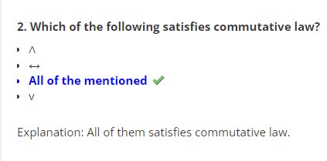ROOM 3

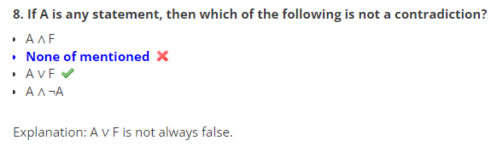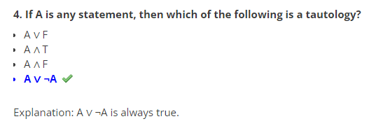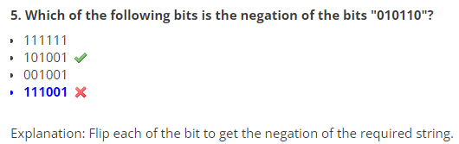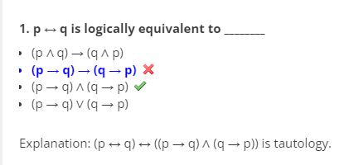

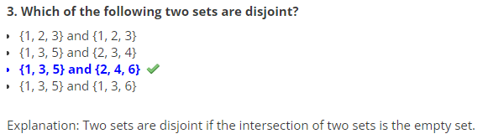ROOM 4

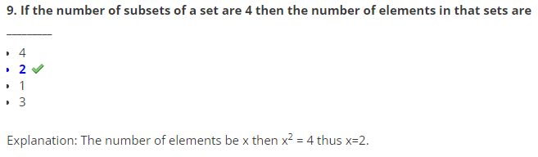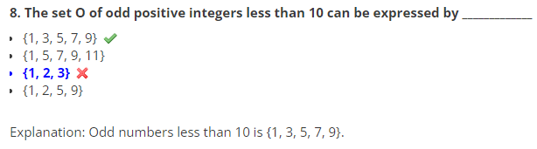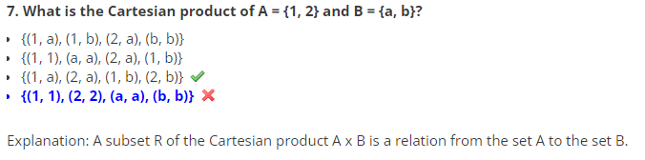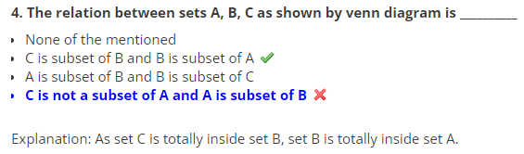

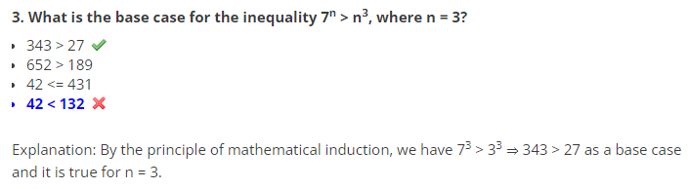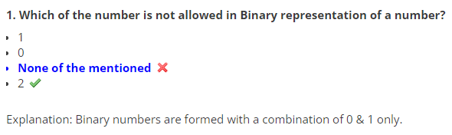ROOM 5

